HEMANT SONI

Present Address | Contact Details |  | 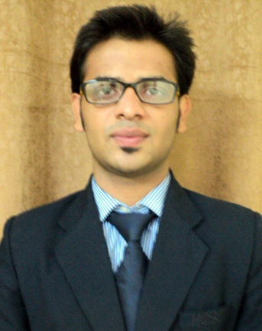
PM-14 Pitambara Nagar, Opposite Water Filter, J.D.A Colony. Jhansi (U.P) | Mobile: | +91-8382873575
 | Other no. | +91-9794866422 -
 | E-Mail: | hemantsn0@gmail.com
Career Objective: | I would always prepare myself for contributing in the progress of organization. The development of the company would be my prime area of interest. It would help me to create a good impression among my companions. I would use my ideology while working. So, I will come to know the strength of my skills
Educational Qualifications: Electrical & Electronics Engineering
Exam | Year | College & Board | Main Subjects | Marks% | Remarks
Bachelor Of Technology | 2011-15 | Hindustan College Of Science & Technology, Mathura (U.P.T.U) | Computer Science And Engineering  (Branch) | 58.96 | Persuing
Intermediate | 2011 | Bhani Devi Goyal Saraswati Vidhya Mandir, UP Board | Physics, Chemistry, Mathematics. | 63.8
High School | 2009 | Bhani Devi Goyal Saraswati Vidhya Mandir, UP Board | Science, Mathematics, English. | 60 | Scored Good Marks in English

Training:
Organization | Training Topic/Assignment | Duration | Remarks
HCL Learning Ltd. | Web Application Development On ASP.NET | 17-Jun-2014 to  28-Jul-2014 | Developed Online Real Estate website by using HTML, CSS and ASP.NET with C#

Professional Skills: | - Good in developing web application.  - Technologies: HTML, CSS, OOPS.  - Programming language: C, Core Java, ASP.NET with C#  - Database: MYSQL , Oracle 10g
Projects: | Online Real Estate Project
Hobbies: | Playing Chess , Travelling new places.

Additional Information / Achievements: |  | - Work as a associate manager in annual fest GyanJyoti’  - Attended Ethical Hacking Workshop.  - Coordinator in Microsoft workshop.
Personal Details |  | Permanent Address / Contact Details
Father's Name: | KAILASH SWARNKAR | PM-14 Pitambara Nagar, Opposite Water Filter, J.D.A Colony. Jhansi (U.P)
D.O.B: | 03-Oct-1993

Language Proficiency: | English, Hindi | Permanent Phone No./ Father’s Phone No  +91-9794866422
Marital Status: | Unmarried | Permanent Phone No./ Father’s Phone No  +91-9794866422


Signature.

